Competitive Analysis of Five University Hub Websites
By Allan Kwan, Jenny Lyons, and Adam Powers

This page contains the competitive analysis that we conducted to structure our own information re-design.
Elements highlighted in yellow were most prominent.
Elements highlighted in red were less prominent, but seemed important to our re-design.

TOP NAVIGATION
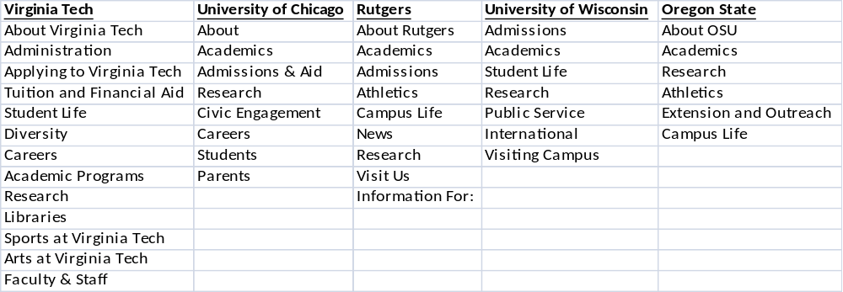

TOP NAVIGATION COUNT
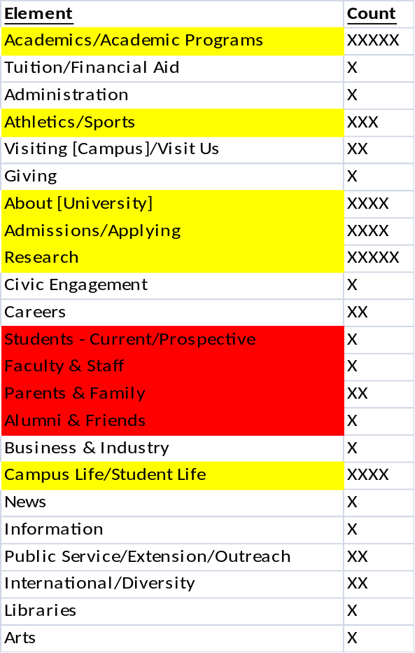

ABOUT
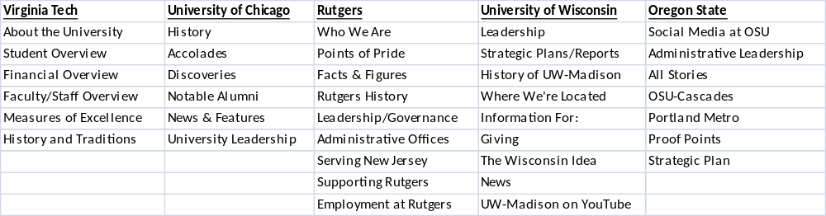

ABOUT COUNT
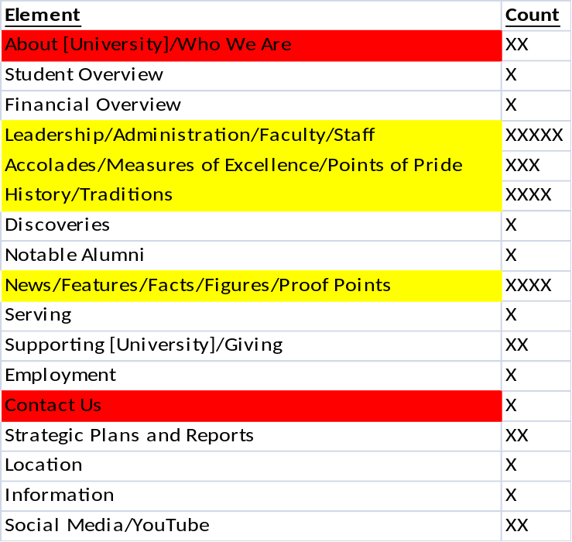

ACADEMICS
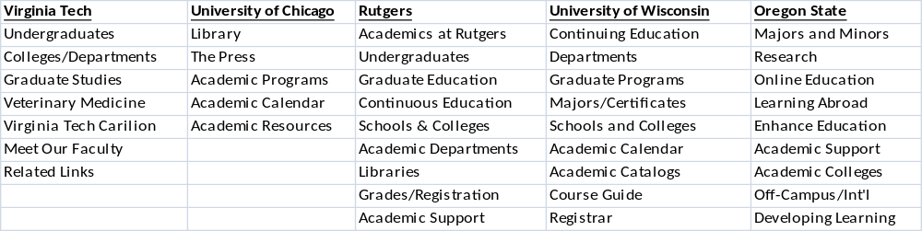
ACADEMICS COUNT
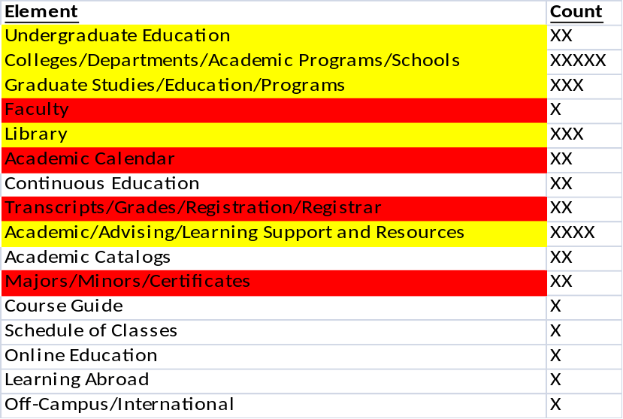

ADMISSIONS
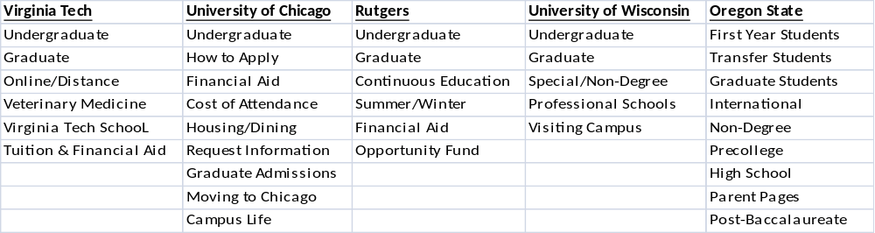

ADMISSIONS COUNT
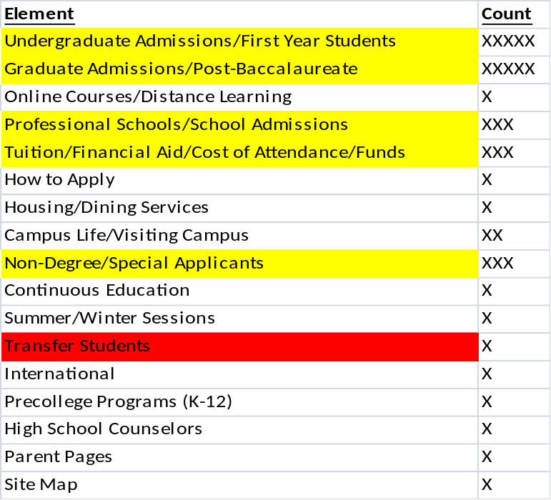

ATHLETICS
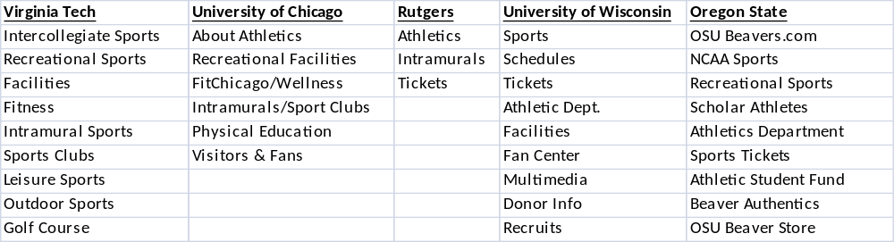

ATHLETICS COUNT
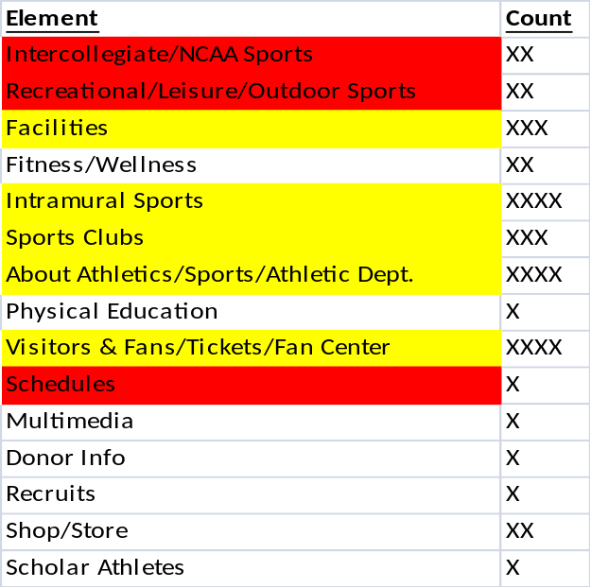

RESEARCH
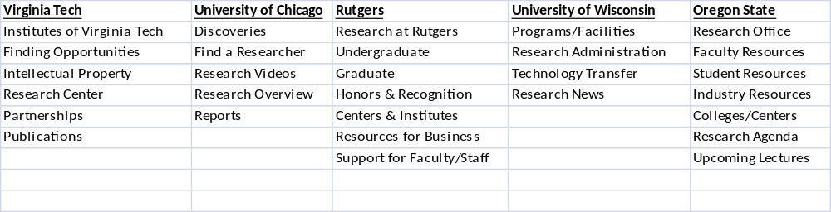

RESEARCH COUNT
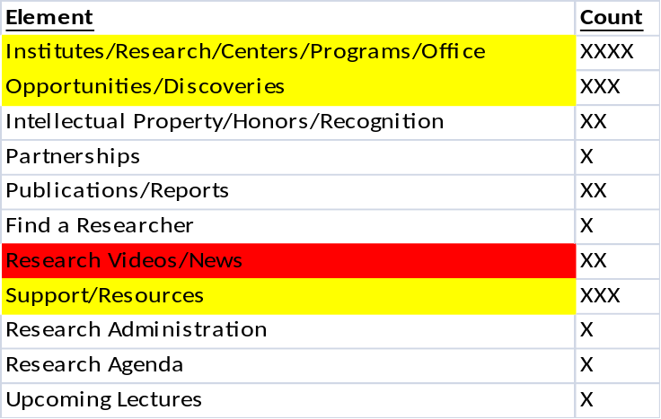

CAMPUS LIFE
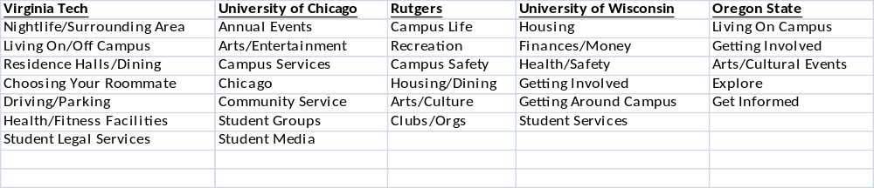

CAMPUS LIFE COUNT
